Article entitled:

Paper ID No:

Corresponding author:

Corresponding Address:

Mobile No: E-mail ID:

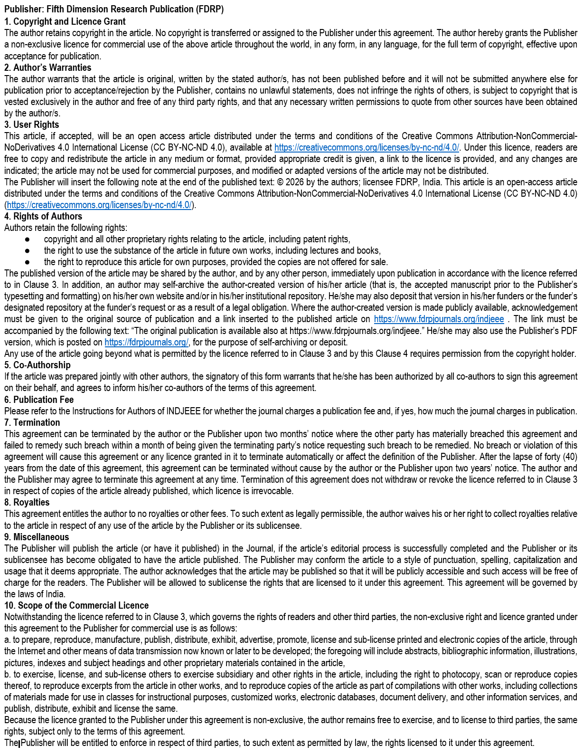

Corresponding author’s signature:

.................................................................................................................................. ................................................................................................

Date:

